INVITATION FOR BID
Prime Minister`s Initiate on Clean & Green Energy

Design, Build and Installation of 300 KWp On-Grid Turnkey Photovoltaic Solar System
For promotion & Development of indigenous renewable energy resources in the country, for improving energy mix and to arrest drain of precious foreign exchange due to import of fossil fuels, the federal government (GOP) under the leadership of the Prime Minister of Pakistan has launched multiple Solar Power initiative. Solarization of Public Sector buildings through transparent competitive bidding process is one of the components of these initiatives.

Federal Board of Intermediate & Secondary Education Invites Bids for design, supply, Installation, Testing & Commissioning of Net Metering Based Solar PV System (300 KWP) at its office in H-8/4, Islamabad from the contractors/Firms registered with AEDB.

Single Stage Two Envelope Bidding Process will be adopted. Bidding documents containing detail terms & Conditions are available at FBISE website i.e. www.fbise.edu.pk for information of potential bidders. The price of bidding documents is Rs. 10,000/-which can be purchased from FBISE on or before 10-03-2023 through Bank Challan/Pay Order in Favor of Secretary FBISE. The bids of only those bidders will be considered who has purchased RFP. All bids accompanied by a bid Security amounting to Rs. 9,000/-per KW and all other documents as specified in the respective RFP must reach the office of Deputy Secretary (Procurement & Store) FBISE on or before March 16, 2023 at 14:00 hrs. The technical bids will be opened on the same date at 14:30 hrs in the presence of bidders representatives who choose to attend at the same address. This is advertisement is also available on www.fbise.edu.pk and www.ppra.org.pk.


(ARSHAD MEHMOOD)
DEPUTY SECRETARY
Procurement & Stores (FBISE)
H-8/4, Islamabad
Ph: 051-9269515

REFERENCE:BISE/ SOLAR / 300KWp
TOTAL PAGES INCLUDING COVER: 30

Bidding Document

FOR

PROCUREMENT OF300KWpROOFTOP ON-GRID SOLAR PV SYSTEM WITH NET METERING FOR FBUSE ISLAMABAD ON TURNKEY BASIS

Sr: # | Description | Part | Pages
1 | INTRODUCTION | PART-A | 2 - 8
2 | INFORMATION AND INSTRUCTION FOR BIDDER | PART-B | 9 - 15
3 | TECHNICAL SPECIFICATION/REQUIREMENT | PART-C | 16 - 20
4 | BID EVAULATION CRITERIA | PART-D | 21 - 22
5 | LIST OF FORMS TO BE SUBMITTED | PART-E | 23 - 30

RFP purchased by : Company Name:

Name and address

Issued by (Name and Signature)

BIDDING DOCUMENT
FOR
PROCUREMENT OF 300KWp ROOFTOP ON-GRID SOLAR PV SYSTEM WITH NET METERING AT FBISE ON TURNKEY BASIS

PART A - INTRODUCTION

FEBERAL BOARD OF INTERMEDIATE AND SECONDARY EDUCATION ISLAMABAD (FBISE) desires to purchase 300KWpRooftop Solar PV on-grid system with net metering on turnkey basis as per following distribution of PV Modules,

ROOFS | UNSHADED AREA FOR SOLAR PV MODULES (SQF) | SIZE OF MODULES ( KWp) CAN BE ACCOMDUATED
ROOF-1 | 6048 | 65
ROOF-2 | 2500 | 27
ROOF-3 | 5600 | 60
ROOF-4 | 3160 | 34
MASJID ROOF | 4300 | 46
ON WINDOW CELL | 4425 | 48
PARKING | 3900 | 42

SPACE AVAILEBLE IS FOR 322 KWp MODULES BUT YOU HAVE TO SUBMIT PROPOSAL FOR 300KWp SYSTEM.

NOTE: You will submit bid in US Dollar and at the time of the contract it will be converted into Pak Rupees as per Bank Exchange rate at the time of signing the contract.

Roof Area-1 in SQF ( 108ft x 56 ft.) =6048 SQF
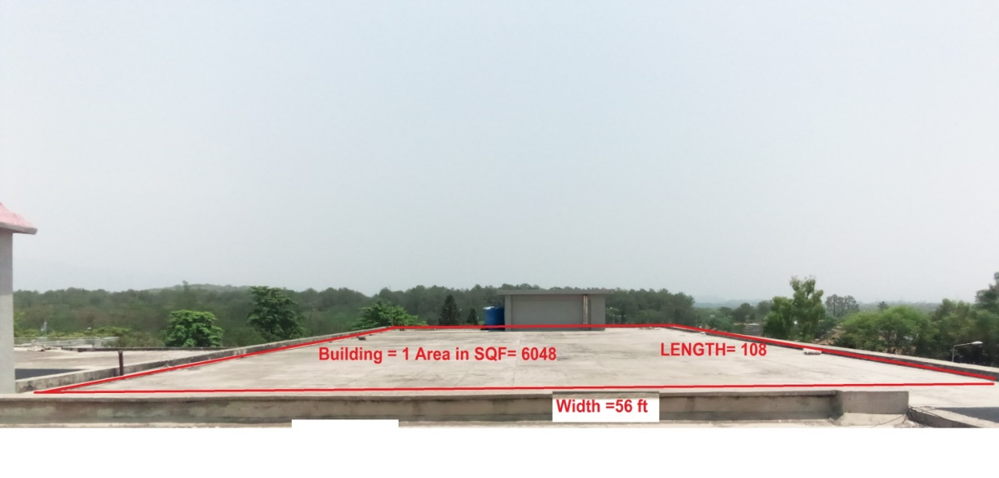

Roof Area-2 in SQF =Lx w (50 x 50) =2500 SQF
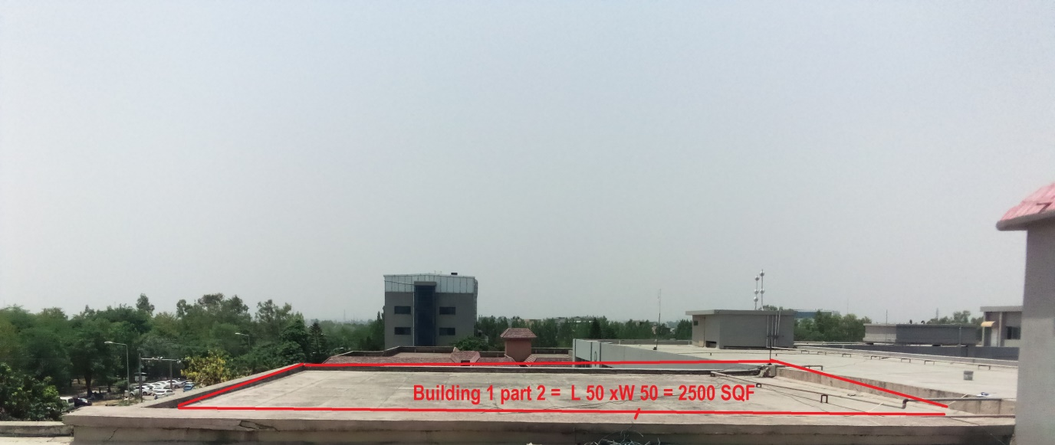

Roof Area - 3 in SQF =Lx w (140 X 40 ) = 5600 SQF
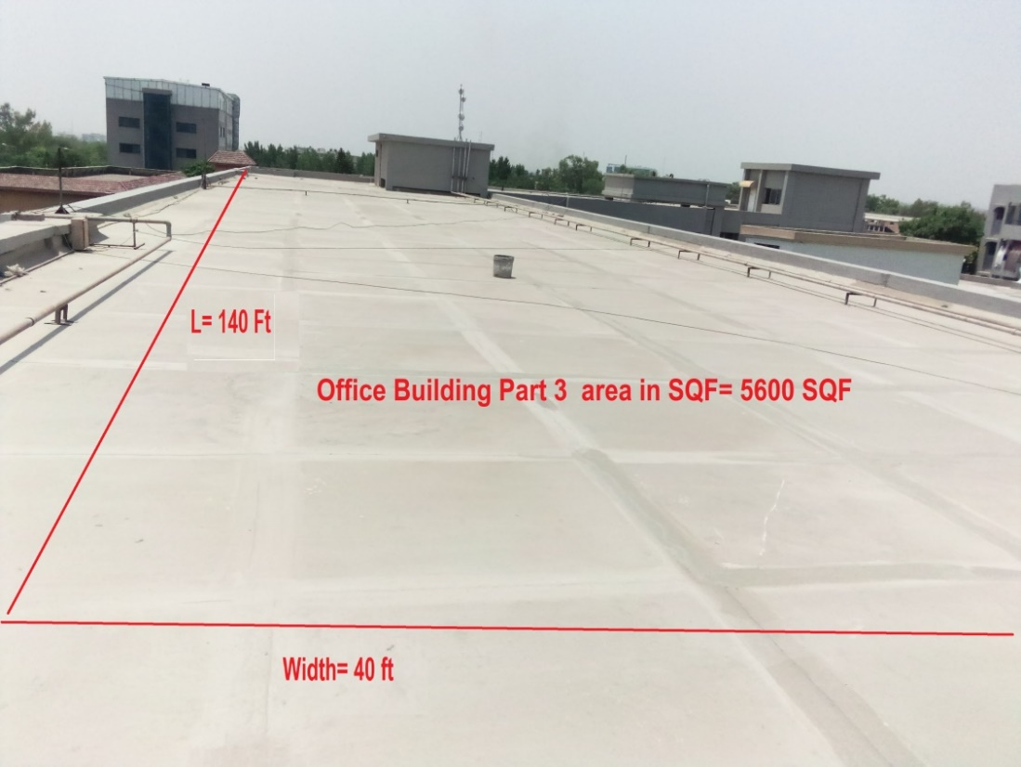

Roof area -4 in SQF =Lx w (79 X 40 ) = 3160 SQF

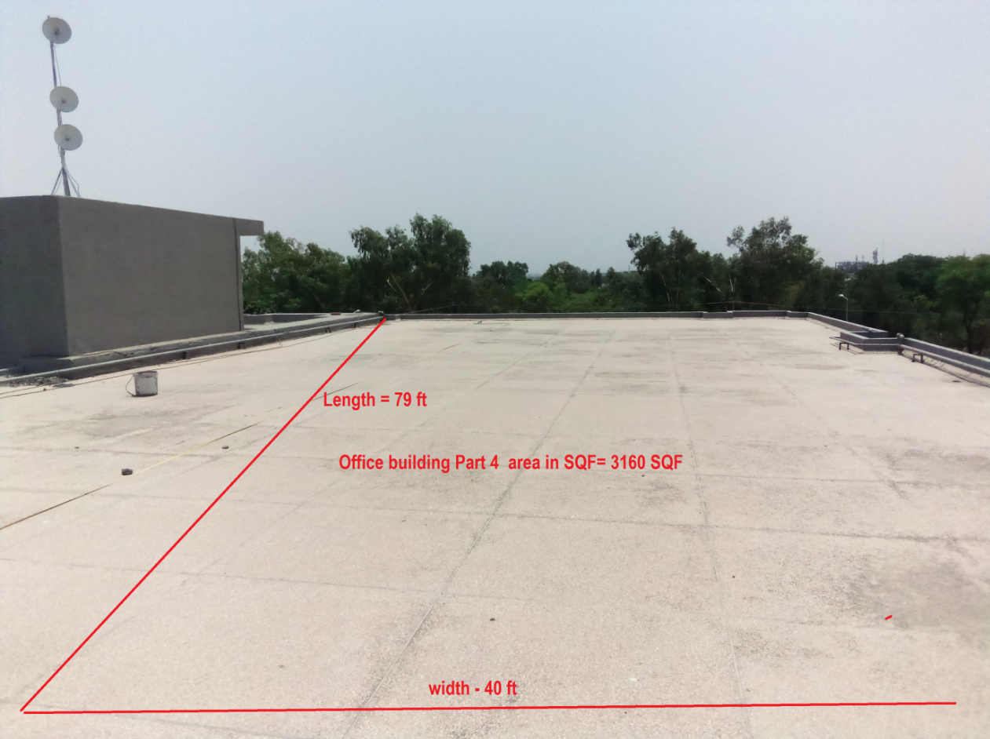

Roof area– 5 - Masjid Roof Area in SQF= 4300 SQF

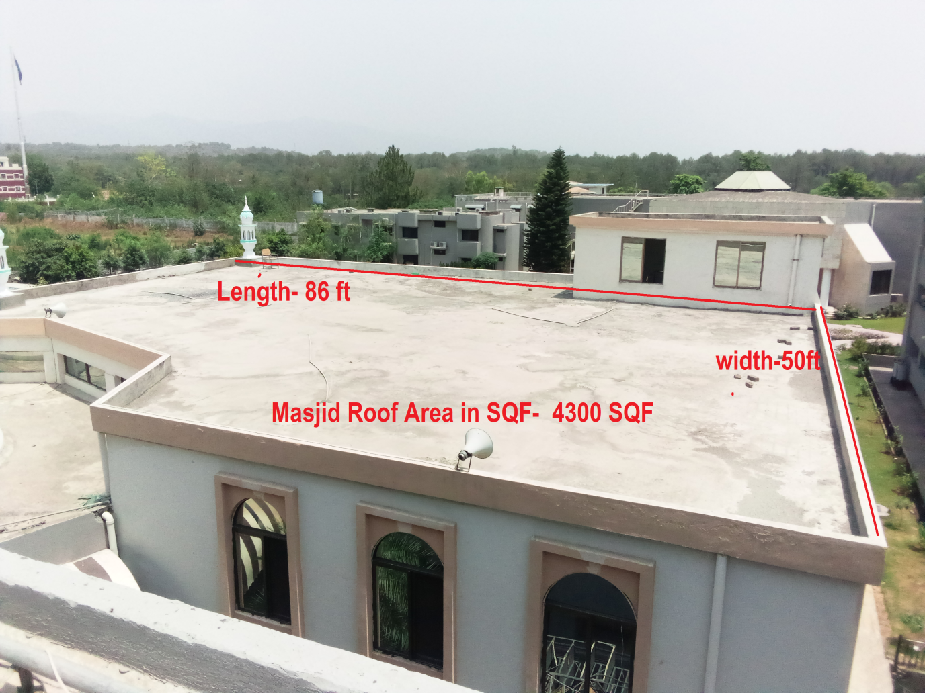

Car ParkingShed area– 6 in SQF=3900 SQF (Optional)

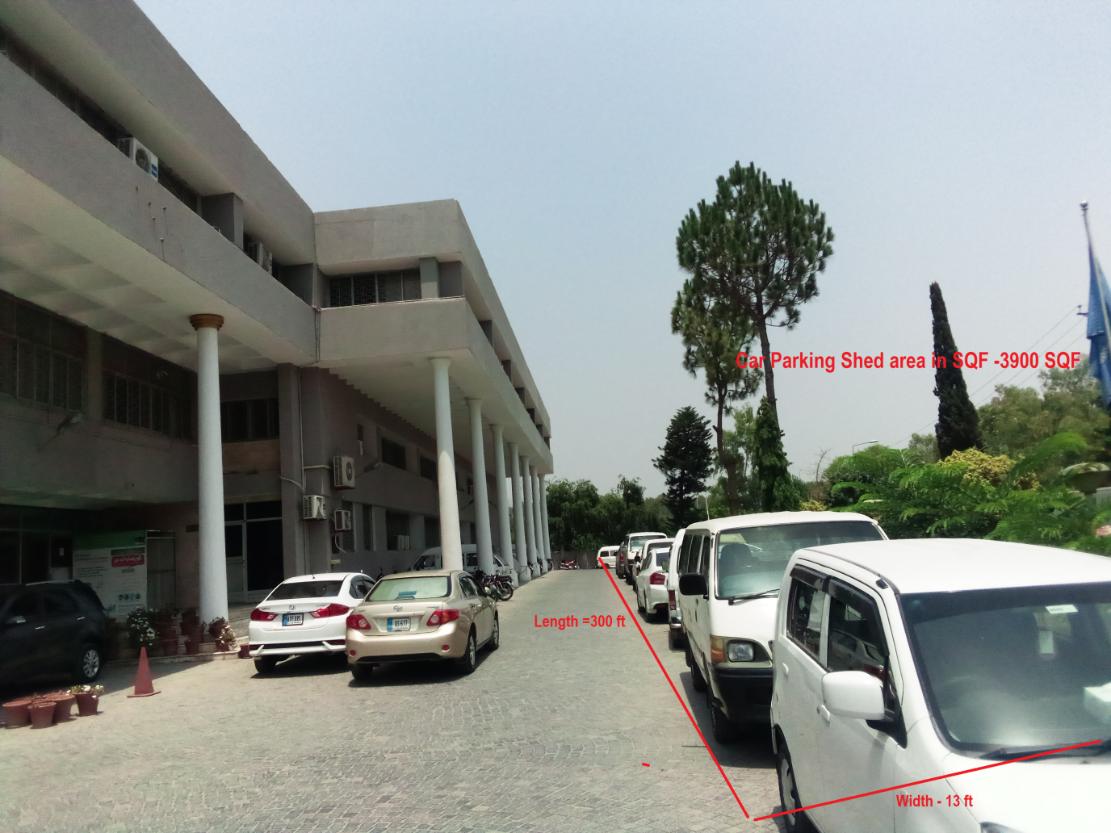

One window Cell Roof Area in SQF-4425 SQF

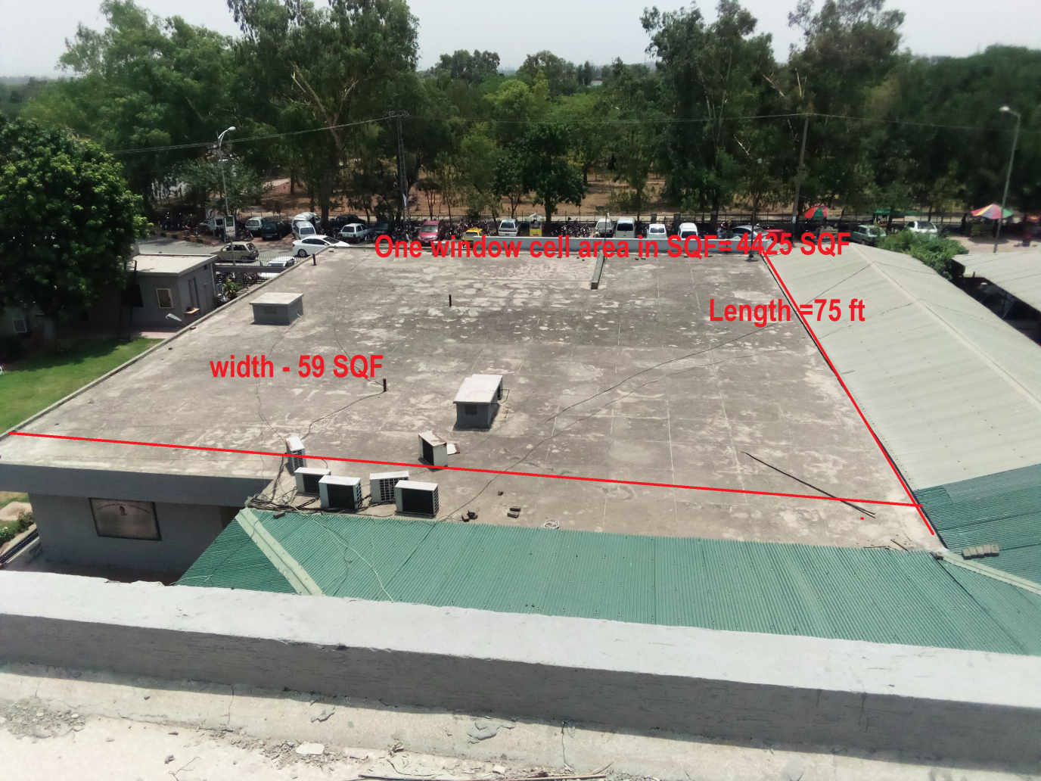

Sanction load of FBISE is 403 KW and one main Transformer of 630 KVA is energizing the whole FBISE Building through a common LV Panel which is 30ft away from Roof areas.
During load shedding Diesel Gen-Set is available which will be synchronized with PV System. Please provide complete PV Diesel Synchronization system enabling automatic start of Gen-Set and synchronized operation of PV system with Gen-Set supplying energy to load in safe manner. ATS is already available.

Solar PV Inverter output will be injected at main LT panel available but Bidder has to provide separate LV Safety Panel dedicated for Solar before injection into the FBISE LT side.
There will be a need for one Net Meter as there is one existing three phase Energy Meter to be replaced with one Net meter.

The bidders must supply LV Safety Panel complete with all protections and switching manufactured by a Quality Switchgear Company as per specifications given in technical specifications PART-C.

Height of building is approx. 25 meter and injection of AC output will be at main LT Panels available at site and bidders have to visit and decide suitable location for Inverter and LV Panel.

The purpose of RFP is to invite Bids from AEDB & PEC Licensed Companies having minimum three years of experience in Solar PV and active NTN/Sales Tax registration with FBR for procurement of aggregate “300KWpRooftop On-Grid Solar PV System at BISE Islamabad.” on turnkey basis as per technical requirement given in Part-C of this RFP.

PART-B. INFORMATION AND INSTRUCTIONS TO BIDDERS

1. Bids must be submitted in one envelope containing two envelopes inside in it.
2. 1stsealed envelope having technical offer be marked as “Technical Bid”.
3. 2ndsealed envelope having financial offer to be marked as “Financial Bid”.
4. Both envelopes to be placed in a one sealed envelope bearing Companies’ postal / email addresses and phone numbers etc. and marked as “Bid for 300KWpRooftop On-Grid Solar PV System on turnkey basis”. Bid should be addressed to

The Secretary, Federal Board of Intermediate and Secondary Education
H-8/4, Islamabad.
5. The project will be implemented on Turnkey basis at rooftops of FBISE on Turnkey basis. Turnkey means design, engineering, supply, installation, commissioning, and trial run with all Civil. Mechanical and Electrical works, warranties, training of client Persons and, after sales services including all permissions and Licenses.

6. 300KWp PV System is to be installed at rooftop of FBISE. By 300KWp solar PV systems means the 300KWp Solar PV modules at STC with total minimum 300 KWp Inverter size complete with mounting structures, DC/AC cables, AC Power Distribution Cabinet (LV Cabinet) with all civil, electrical, and mechanical work on turnkey basis with five years free service (Labor and material). Service means the availability/visit of service person as and when any fault occurs in any part of the system for fault diagnosis/ repair/Replacement. Response time is within 24 Hours after receiving call/sms/email. Service does not include cleaning of PV modules.

7. The technical proposal must have BOQ of system and the financial proposal should have prices for same system as per Form C and D. (Mandatory)

8. Bidders have to provide one Original hard copy for Technical and one Original hard copy for financial bid and one soft copy of technical bid only in USB. (Mandatory).First the Technical bid will be opened and technical evaluation will be made as per PART-D then Financial Bid will be opened for only Technically qualified Bidders and bids will be returned to Technically non-qualified bidders.

9. All bidders shall provide complete Technical BOQ in Technical bid as per FORM C of this RFP (Name of Each Item, Description of Each Item, Brand Name, Country of Origin, Manufacturer Name, Model and QTY) duly signed and stamped (Mandatory). Complete BOQ in Technical bid as per Form C is Mandatory for qualification of Bid and Bids will be rejected without Form-C. Technical BOQ must consist of Solar PV modules with MC4 cables and connectors, solar on-grid Inverters, Solar Mounting structure (as per PV modules), Combiner Boxes with fuses/circuit breakers, PV DC Cables, AC Cables, AC Power Distribution Cabinet (must contain circuit breakers, Contactors, Surge Arrestors, Manual On-OFF switch, Unidirectional Energy (KWh) Meter, Voltage, Current and Bus bars complete with cabling and fittings and accessories. Bidders will not be allowed to change brands after the Bid submission. One primary and one alternate brand is allowed for Solar Modules only and for remaining components only one brand/manufacturer is allowed. The word equivalent in not allowed at all. (Mandatory)

10. Quality of solar system will be judged from the best organization of Bid, Quality of system components, SLD (Single Line Diagram up to the point of Injection), and completeness of BOQ and designed AC Injected Energy in terms of KWh per year for 25 years calculated through simulation software Solar PV SYST. The design report must include shading analysis, PV modules arrays, PV Mounting structure AutoCAD drawing converted in pdf showing front, top and side views with gauges, tilt angle, material, Specific Yield KWh/KWp, monthly and yearly AC Injected Energy, Inverters layout/Configuration, details of Losses from PV Modules to grid Injection etc. Designed AC Injected Energy to Grid submitted by Companies through design software will be taken as yearly committed Injected energy and will be reflected in the contract as minimum guaranteed Energy. AC Energy injected in first year should not be less than 4KWh/KWp/day (to be calculated by dividing the total first year AC energy by 365 days). The energy committed for first year will be measured after one year of operation starting after net metering and AC energy will be measured for future years after accounting for degradation of 0.7% each year and bidders will pay the penalty for less energy output from its Minimum Generated Energy (MGE) and it will be calculated by multiplying deficient KWh with Grid of-peak tariff of DISCO at that time.

11. Financial Bid must indicate turnkey price system as per FORM-D including all applicable taxes and duties and separate price of each component is not required.

12. Financial Bid must be submitted strictly as per FORM-D of this RFP at Bidder Letter Head duly signed and stamped in separate sealed envelope: (Mandatory)

13. Bids must have minimum validity of at least 30 days.

14. Solar PV modules must be of Tier-1 as per BNF LIST 2020 with minimum 10 years replacement warranty and 25 years’ performance warranty with annual degradation of not more than 0.55%, Inverters should have minimum five years’ warranty and whole system should have minimum five years’ warranty with free labor and parts.
15. Technical Bid must include following documents-
- Copy of valid AEDB Certificate (Mandatory)
- SECP Registration copy of Company incorporation. (Mandatory)
- Valid PEC registration Certificate in Solar category. (Mandatory)
- Valid Income and sales tax registration certificates. (Mandatory)
- List of 100KWp or more projects (On-grid Solar PV Plants) completed in last three years with date of completion and name of the customer with address, Cell and phone contact with email address as per Form- B.(Irrelevant or non-solar PV plant related projects list or data or any attachment can result in rejection of Bid).
- Quality Certification(s) as per IEC standards for each component of the system.(Mandatory)
- List of three trained graduate engineers (one electrical, one mechanical and one Civil) having more than three years’ experience of working on Solar PV Plant and copy of valid membership card of Pakistan Engineering Council. (Mandatory)
- System design report generated through solar PV simulation software PV System with year wise AC energy Injection in Grid for 25 years. (Mandatory)
- Forms A, B, C and D duly filled and stamped(Mandatory)
- Non-refundable RFP Price of Rs.10000 and Earnest money of Rs:1200000/- (Rupees 1.2 Million) in the form of DD (Demand Draft) to be included in technical Bid in favor of Secretary Federal Board of Intermediate and Secondary Education Islamabad.
- Technical datasheet of each component of Solar PV System offered.

16. The completed work will be verified by consultant as per RFP and Contract. Some Salient verifications/measurements are as follows: -
a. Complete Documentation as per RFP.
b. Quality of System Components, Quality certifications, Energy commitment, Quality of system design report, Quality of workmanship during installations, Solar Mounting structure design and materials, Service Workers and Engineers Behavior at work, Quality of interactions of staff of the Companies with Askari-V
Staff and labeling and tagging of cables and connectors.
c. Compliance with Bid specification and RFP terms.

17. Bidder shall be responsible for all the clearances and transportation of equipment up to/ within FBISE premises and provisioning of labor for loading/ un-loading would be the responsibility of the Bidder.

18. Subletting/Joint Venture (JV)/Consortium are not allowed by the Bidder and it will lead to disqualification of the Bid without any hearing or representation from the Bidder.

19. Submission of Bids through email / fax is not admissible.

20. Bids cannot be with-drawn after submission.
21. The supplied items must have service and operations manuals and operating software for the components of the system and communication gadgets.

22. Bids shall be rejected if BOQ as per Form-C and Prices quoted as per FORM-Dare incomplete, unclear, conditional, altered, or ambiguous.

23. Bids shall be rejected if required detail of specifications, brand, origin, make, model, warranty, free service etc. are not clearly quoted / mentioned. No margin shall be given on this account.

24. Late submissions would not be entertained at any cost.

25. RFP document is only an invitation to offer Bids. The competent authority may reject all Bids or cancel the RFP without any reason.
26. Purchaser will provide place for safe storage of equipment.

27. The completion time from contract signing to commission in and Trial run should not be more than 12weeks from the date of signing of contract. This period does not include Net Metering time. (Relaxation may be granted as per merit of the case). Trial run will be 10 days after net metering of the system.

28. In the event of any delay in completion period beyond 12weeks, the Bidder shall in form Purchaser before expiry of such period giving reasons / justification for delay. However, purchaser reserves the right to take following actions: -
a. Evaluate their quest for extension in completion time as per its merit and may consider extension in completion period or otherwise.
b. In case of late completion for the reasons well within control of the Bidder, liquidation damages at the rate of 1% per week but not exceeding 10% of the total value of the undelivered stores / items may be levied.
c. May cancel the contract.
d. The purchaser’s decision under this clauses hall not be subjected to arbitration.

29. Purchaser Inspection Committee including Solar Consultant will inspect and test the supplied Items as per this RFP after arrival at the premises.
30. Payment Milestones
- 20% Mobilization Advance at the time of signing of contract
- 45% upon Submission of original purchase invoice alognwith Flash Report and certificates after inspection/satisfactory report by Agency’s Representative
- 20% installation of PV system without net metering.
- 5 % after successful trial run of 10 days after Net Metering.
- 5% after performance evaluation of system upon its completion of first year.

31. Bid Receipt and Opening. Single Stage – Two Envelop would be adopted for opening of the tenders. Sealed envelope must reach on mentioned address by 1400 hrs on or before 16 March 2023

32. Pre-Bid Meeting Will Not Be Held. Written queries will be addressed till three days before the Bid submission time.

33. For Queries (If Any): Bidders may contact Mr. Arshad Mahmood
Deputy Secretary (Procurement and Stores), Federal Board of Intermediate and Secondary Education, H-8/4 Islamabad
Tel: 0333-5522729
Email: dsg@fbise.edu.pk
34. Warranty and Free Services. Bidders shall provide minimum five years warranty of the whole system with free service (Labor and Parts) in addition to different warranties of the solar PV system components effective from the date of successful installation and commissioning of the System. Whole system warranty will be on bidders’ letter. Bidders will be responsible for all repair works with parts on its own arrangements and expenses during the warranty period.

35.Certifications and Test Reports. The Bidder will provide flash report of solar PV modules and complete test report from accredited Lab of quoted solar PV modules as per IEC Standards 61215 and 61730 latest edition, IEC Certifications of Inverters mentioned in the RFP and all certifications mentioned in the RFP for all other components. Bidder will provide certificate of origin issued at manufacturer’s letter head for solar PV modules and Inverters. Purchaser shall have all the rights to get tested or verified from Laboratories any system component as per standards mentioned in the tender. Purchaser can ask any time any verification and confirmation letter from manufacturer for manufacturing and supply of any component of Solar PV System.

36. After Sales Services and AC Energy Injection
a. Bidder will guarantee the availability and the supply of Essential Maintenance Spares required to keep the equipment operational for a period of 10 years.
b. The Bidder would provide free after sales services (Material and Labor) of whole system for five years starting from the date of installation with net metering. Bidder will provide from up-gradation of software or improvements enhancing the efficiency of the system during warranty period.
c. Bidder will guarantee AC Injected energy output not less than 3.8KWh/KWp/Day average upon completion of first year in sunny days and minus the load shedding period(Total KWh in first year divided by 365) and for next years by accounting for degradation of 0.7% each year. Bidders can increase the PV modules from Given STC sizes to achieve minimum AC Guaranteed Energy of 4 KWh/KWp/Day or for string balancing. Preference will be given to bidder committing MGE of 4 KWh/KWp/Day upon completion of first year from the date of activation of Net Metering.

37. Taxes, permissions, and Licenses. Bids should include all the taxes, duties, permissions, and Licenses.

38. Packing & Transportation. All PV System Components shall be individually packed in standard packing provided for onwards transportation and delivery to site. Any item damaged during transportation will be replaced by the bidders at their own cost all inclusive.

39. Technical / User Manual/BOX File. Successful Companies will be bound to provide technical and operational manuals at the time of delivery. Before final inspection, the bidder has to provide one BOX file with complete documentation including copies of RFP, contract, data sheets of all components, company sales and service contacts with cell, emails, inspection report and this will be the reference Box file available to all.

40. Tool Kits / Accessories / Operations & Maintenance Manuals. Standard sets of General Tool kit / accessories/ Operations and Maintenance manuals of the system shall be supplied by the Bidder within the quoted price.
41. Arbitration. In case of any dispute, case shall be reviewed by Purchase Inspection Committee including Solar Consultant and Bidder’s CEO or its representative, decisions hall be final and binding on both the parties without recourse to legal action.

42. Litigation. In case of any un-resolvable dispute only Islamabad court of Law shall have the jurisdiction to decide the matter.

43. Force Majeure. The Bidder shall not be held liable in the event of their failure to comply with the delivery schedule of the ordered items(s) for reasons of Force Majeure including but not limited to: war and other instabilities invasion, act of foreign enemies, mobilization or embargo, civil war etc.

